Self Driving Car

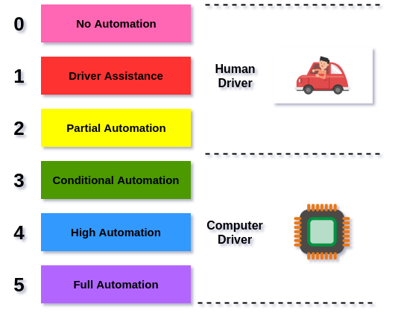

* **Level 0**: All functionality and systems of the car are controlled by humans
* **Level 1:** Minor things like cruise control, automatic braking, or detecting something in the blind spot may be controlled by the computer, one at a time
* **Level 2**: The computer can perform at least two simultaneous automated functions, such as acceleration and steering. A human is still required for safe operation and emergency procedures
* **Level 3**: The computer can control all critical operations of the car simultaneously including accelerating, steering, stopping, navigation and parking under most conditions. A human driver is still expected to be present in case they are alerted of an emergency
* **Level 4**: The car is fully-autonomous, without any need at all for a human driver, in some driving scenarios. For example, the car can fully drive itself when it’s sunny or cloudy, but not when it’s snowing and the lanes are covered
* **Level 5**: The car is completely capable of self-driving in every situation

Sensor(Eyes of the car)

1. Camera- HD , capture images
2. Radar- speed and distance- radio waves to detect objects
3. LiDAR stands for Light Detection and Ranging- light waves to measure distances

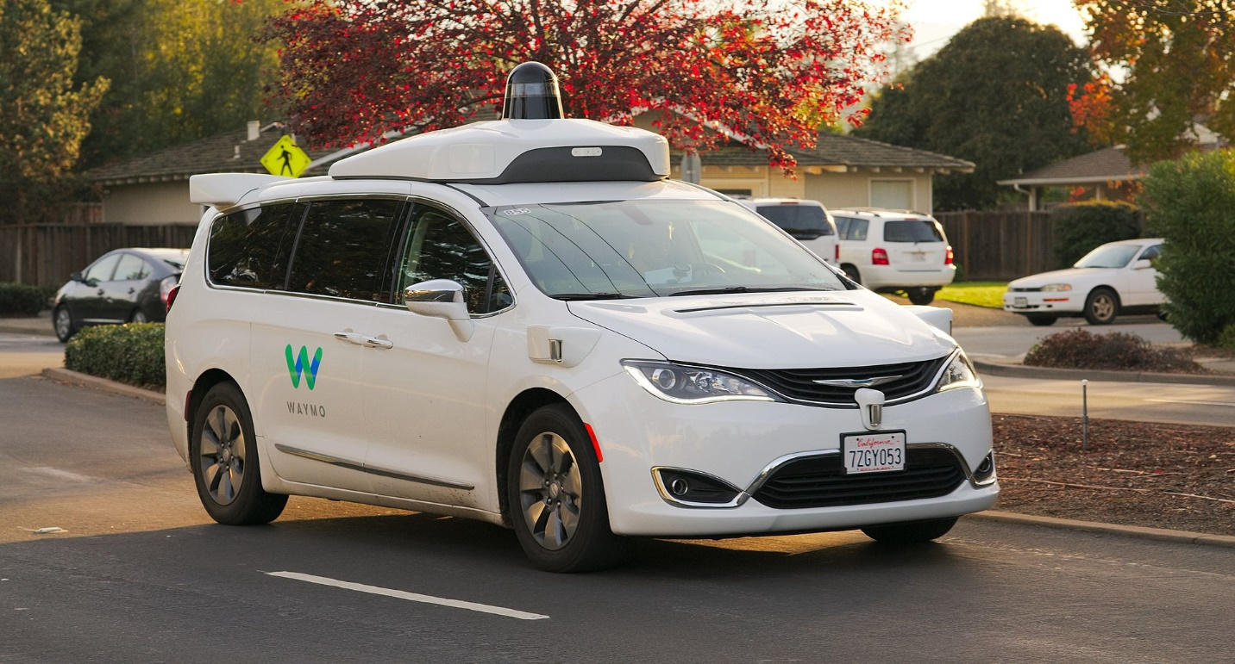

Deep Learning- Large neural networks- Computer Vision, Image Classification, Object Detection, Scene Segmentation, and Driving Lane Detection

Path planning. The goal of path planning is to use the information captured by the Computer Vision system to safely direct the car to its destination while avoiding obstacles and following the rules of the road

